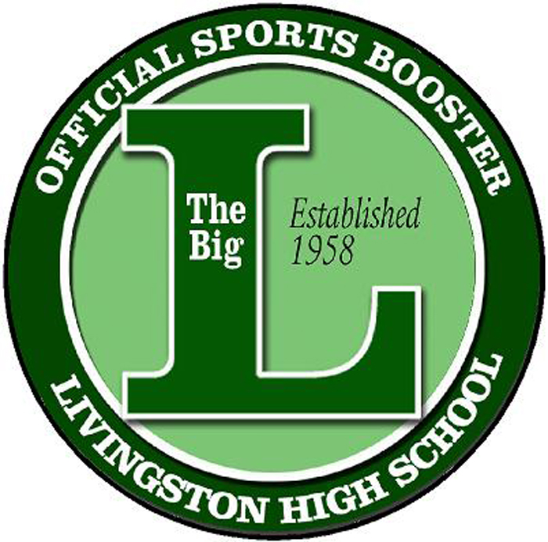

The Big L Club
PO Box 284
Livingston, New Jersey 07039
TheBigLClub@gmail.com
501 (c) 3 Not-For Profit Orga nization
October 2017

The Big L Club Organization will be hosting its 3rd annual Casino Night on January 19th , 2018 and its 17th annual Taste of Livingston Senior Athlete Fashion Show/Tricky Tray on May 8th , 2017. These events bring together the Livingston Community in an effort to Support our Livingston High School Athletes and our Athletic Program.

In June at our Pep Rally, The Big L Club will provide recognition of all our Senior Athletes as well as Special recognition for our Male and Female Athlete of the Year, Cherenson, Livak and Lagowitz award recipients. Each award is presented to the students who have demonstrated leadership, good character, integrity, sportsmanship and teamwork.

In addition, to recognizing the Senior Athletes, the money raised will be used by The Big L Club to purchase a gift that will benefit the entire LHS Athletic community. In the past, we have gifted exercise equipment for the fitness and wellness center, helped purchase the softball scoreboard and golf cart for our LHS sports trainers, donated a Hall of Fame Wall which proudly presents all of our time honored athletes in the wellness center. The Big L provided video cameras and software for all of our LHS coaches and teams to use for instructional purposes as well as two portable speakers and a tunnel of success were donated for all teams to use for their big games. To boost the spirit of LHS, The Big L Club has purchased a mascot, Sir Lawrence the Lancer. Sir Lawrence attends various school and sporting events through out the year. Most Recently, a portable scoreboard, a donation to the baseball dugouts, and The big L snack shop were donated. The Snack Shop will provide FREE snack to all our in season atheletes so they can refuel after school before a game or practice. The LHS Athletic community hopes that you will participate in these events and help the organization reach its goal - its success depends on your generosity.

Premier Sponsor- $2,500
• Your Company name on the front cover of each event booklet (i.e. Big L Casino Night
Sponsored by...)
• Full page ad in the event booklet for both events
• Premier Signage at both events high traffic areas (2 Signs)
• The opportunity to provide one piece of marketing material in the goody bag • One Year of Advertisement on our webpage
Grand Sponsor- $1,000
• Premier Signage at both events (1 Sign)
• Full page ad in the event booklet for both events
• The opportunity to provide one piece of marketing material in the goody bag
Table Sponsor - $500
• Your company name on a table sign for both events
• Your company name listed in the event booklet for both events.
• The opportunity to provide one piece of marketing material in the goody bag

*All contributions are tax deductible as permitted by law. Our Tax ID # is 81-1150576.
Donations should be made payable to The Big L Club and mailed to: PO Box 284, Livingston NJ 07039 – Attn: Carla Cheesman. For more information visit our website www.TheBigLClub.org

Any questions or concerns you can contact us at TheBigLClub@gmail.com and to ensure publication of your generosity.
We thank you in advance for your consideration to make The Big L Club’s fundraisers a great success.

Sincerely,
The Big L Club

The Big L Club
PO Box 284
Livingston, NJ 07039

Thank you for your Sponsorship to the The Big L Club

This is your receipt:

Date: ________________________________________________________

Premier Sponsor $2,500: ____________________________

Grand Sponsor $1,000: _____________________________

Table Sponsor $500: _______________________________

Partial Table Sponsor $100: _________________________

Sponsorships need to be received by January 1, 2018

Tax Exempt I.D. #: 81-1150576

- - - - - - - - - - - - - - - - - - - - - - - - - - - - - - - - - - - - - - - - - - - - - - - - - - - -
Lower portion to be filled out by Sposonsor and turned in with the gift.

Sponsor’s Name _______________________________________________

Company Name ______________________________________________

Street Address _______________________________________________

City ________________________ State ___________ Zip ____________

Phone ______________________________________________________

Sponsorship Level ________________________________________________

Value ______________________________________________

Big L Member Solicitor ______________

