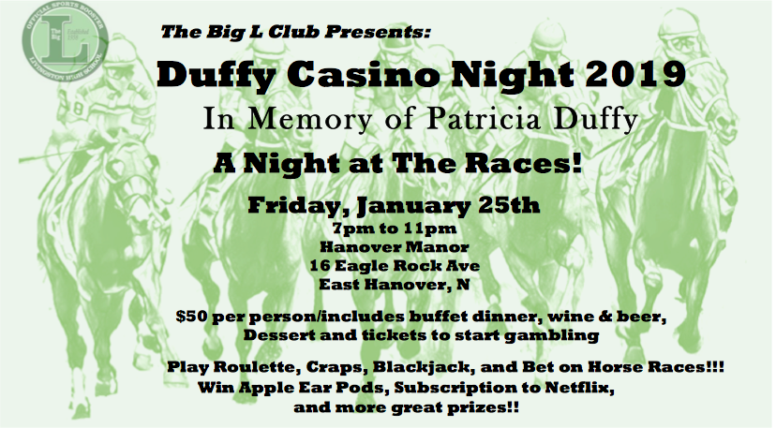

Duffy Casino Night Registration Form
RREGISTRATION INFORMATION

NAME__________________________________________________________________

Company ______________________________________________________________
Address________________________________________________________________

Phone ______________________________________email_________________________________________________

Total # of People $50 pp _________

Donation __________

Premier Sponsor $2,500 _________

Table Sponsor $500_________

Partial Table Sponsor $100 ________

Horse Sponsor $25 ________

Total amount enclosed______________

PAYMENT OPTIONS – tickets sold at the door will be $55 pp

PAYMENT CAN BE MADE BY CHECK OR CREDIT CARD ON www.thebigclub.org

4% processing fee will be added to credit card charges

PLEASE CHECKS PAYABLE TO:
The Big L Club
P.O. Box 284
Livingston, NJ 07039

ADVANCED PAYMENTS MUST BE RECEIVED BY JANUARY 9th

Questions; Please email : thebiglclub@gmail.com

www.thebiglclub.org

ALL PROCEED GO TO BENEFIT THE LHS ATHLETIC DEPARTMENT AND OUR STUDENT ATHLETES
Thank you for your Support !

